Entartete Kunst (Degenerate Art)
Entartete Kunst (Degenerate Art) is a term that was used by Nazi authorities to identify, censure, and confiscate art they considered inconsistent with their ideology. It was the cornerstone of an ambitious propaganda campaign that culminated in the exhibition Entartete Kunst, which took place in Munich in 1937. The majority of this so-called degenerate art was AVANT-GARDE in both form and subject. ABSTRACT ART by German artists, including MAX BECKMANN, MAX ERNST, ERNST LUDWIG KIRCHNER, PAUL KLEE, and FRANZ MARC, was particularly vulnerable to Nazi attack; non-German artists such as VASILY KANDINSKY and PIET MONDRIAN were also singled out. As a polarizing concept, Entartete Kunst stems from an essentially anti-modernist, xenophobic and anti-Semitic position. It was designed to legitimize the art of the Third Reich, which was rooted in traditional art forms and characterized by an idealized naturalism that promoted heroic virtues and racial purity.

Also see AVANT-GARDE, MAX BECKMANN, MAX ERNST, ERNST LUDWIG KIRCHNER, PAUL KLEE, OSKAR KOKOSCHKA, NAZI MODERNISM, FRANZ MARC, PIET MONDRIAN, and PRIMITIVISM.

Policy and Legislation
The bureaucratic structures that Adolf Hitler and his surrogates established to legislate Entartete Kunst were wide-reaching, disciplined, and destructive. Soon after Hitler came to power in 1933, a number of artists, who were later labeled “degenerate,” were dismissed from their teaching positions. Several prominent museum directors were also dismissed due to their support for AVANT-GARDE art. Joseph Goebbels established the Reichskulturkammer (Reich Chamber of Culture) that regulated cultural matters including the visual arts. Under his leadership, the Deutscher Kunstbericht (German Art Report) was published in 1933 and proclaimed: “All works of a cosmopolitan or Bolshevist nature should be removed from German museums and collections, but first they should be exhibited to the public, who should be informed of the details of their acquisition and then [the artworks should be] burned.” This report anticipated the systematic confiscation of Entartete Kunst, which began in 1937, from museums, galleries, and private collections. It also predicted the planning and mounting of exhibitions throughout Germany devoted to “degenerate” art. This campaign was, however, not without certain contradictions. For instance, Goebbels was covertly ambivalent about some of the AVANT-GARDE artists he was tasked with denouncing, and the Reich profited from the sale of confiscated artworks it had earlier vowed to burn.

Exhibition and Impact on Artists
On July 19, 1937, the exhibition Entartete Kunst opened in Munich the day after the nearby Grosse Deutsche Kunstausstellung (Great German Art Exhibition) opened in the Haus der Deutschen Kunst. The proximity and timing of these opposing exhibitions were meant to amplify the Reich’s message of cultural purity. Artworks freshly purged from museum collections were featured in Entartete Kunst on walls that displayed tendentious slogans such as: “Nature as seen by sick minds,” “An insult to German womanhood,” and “Revelation of the Jewish racial soul.” The cover of the exhibition brochure featured a sculpture by the AVANT-GARDE artist Otto Freundlich, whose PRIMITIVIST aesthetic and Jewish identity were anathema to Nazi ideology. Entartete Kunst cost many of the artists it represented their homeland and, in some cases, their lives. On the day the exhibition opened, MAX BECKMANN fled to Amsterdam and never returned to Germany; MAX ERNST eluded the Gestapo in France and emigrated to America. In 1938, ERNST LUDWIG KIRCHNER committed suicide and in 1943, Otto Freundlich was killed in a concentration camp.

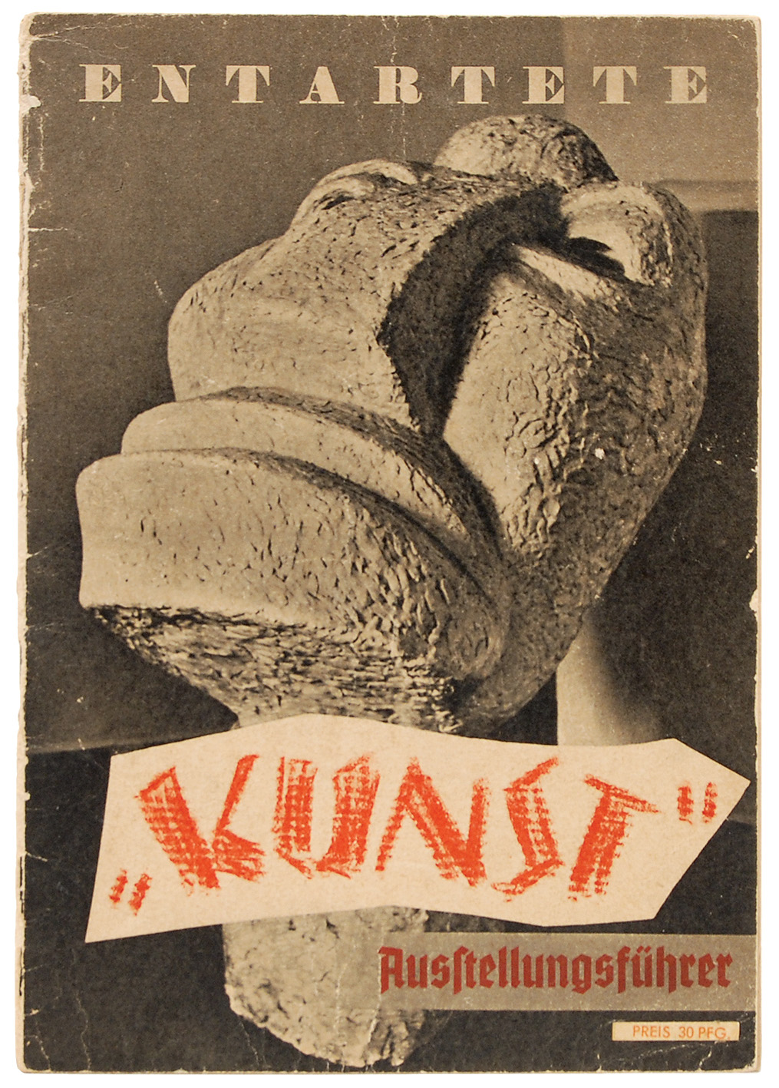Cover of Ausstellungsführer Entartete “Kunst” (Exhibition Brochure, Degenerate “Art”) by Fritz Kaiser, 1937

Key Reference Works:
Adam, Peter. Art of the Third Reich (1992)
Barron, Stephanie, ed. “Degenerate Art”: The Fate of the Avant-Garde in Nazi Germany (1991)
Bussmann, Georg, ed. Kunst im Dritten Reich: Dokumente der Unterwerfung (1974)
Fleckner, Uwe, ed. Angriff auf die Avantgarde. Kunst und Kunstpolitik im Nationalsozialismus (2007)
Kaiser, Fritz. Ausstellungsführer Entartete “Kunst” (1937)

